Dept. of Biomechatronics Engineering, National Taiwan University
Intelligent Control
Homework 3
- Further familiar with the programming for fuzzy control using Python and skfuzzy toolbox (Problem 1)
- ANN for XOR (Problem 2)
Pages: 3
Deadline: 14:00, March 30th

- Design the controller of an air conditioner by writing a Python program wth skfuzzy toolbox to maintain the desired room temperature as the figure. The fuzzy controller should meet the following requirements:
(1) Identify input and output variables. Analyze and simplify problem: two input variables of the controller: a. the difference (error) between the current room temperature and desired room temperature; b. the room humidity. One output variable of the controller: the compressor running time of the air conditioner.
(2) Define membership functions. All input and output variables should have at least three membership functions.
(3) The universe of discourse of those variables: temperature= [5, 40]℃, humidity=[20, 90]%, running time=[0, 10]min.
(4) Write rules. Observe model behavior, begin verification, tune as needed and optimized system.
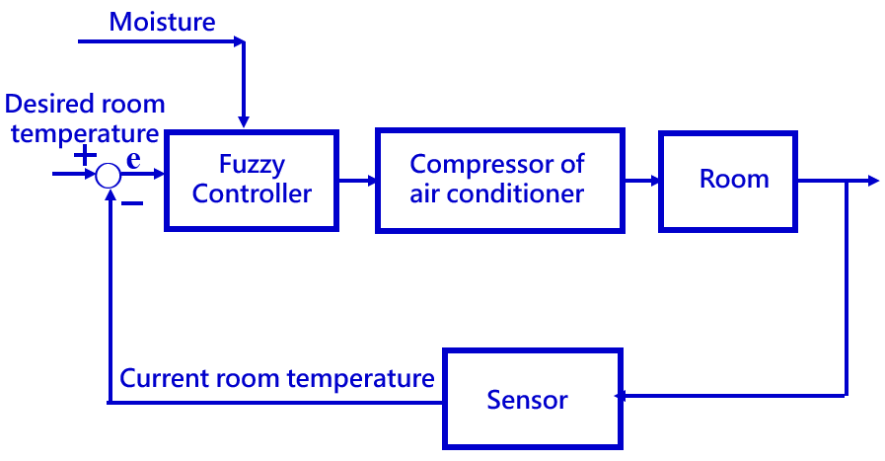
2. It is given that the relationship between input and output of an XOR problem is as follows:

No. | Input1 x₁ | Input2 x₂ | Output Y_{d}
 | -1 | -1 | 0
 | -1 | +1 | 1
 | +1 | -1 | 1
 | +1 | +1 | 0

- The network architecture (no hidden layer), initial weights W₁₁, W₁₂, threshold θand learning rate ηare as follows:
Y

W₁₁
W₁₂

x₁
x₂

Initial weights W₁₁=1, W₁₂=‐1, and θ=0, η=0.1
Try to use this structure to see if it can solve the XOR problem. And list the relevant values of the learning process, x₁, x₂, Y, Y_{d}, the weighted product and the inferred value of net, Y=1 when net>0, Y=0 when net≦0, the difference between Y_{d} and Y, δ, ΔW₁₁, ΔW₁₂, Δθ, W₁₁, W₁₂, and θ.
(2) For the following two network architectures (both with hidden layers), use the backward propagation network method to fill in appropriate weights and thresholds to solve the XOR problem.
Network1 Network2
Y
Y

W₅₄
W₅₃
W₄₂
W₄₁
W₄₃
W₃₂
W₃₂
W₄₂
W₃₁
W₃₁
W₄₁
x₁
x₂
x₁
x₂

Y_{d} is the standard value, the inferred value of Y_{d} is Y, and the difference value δ is as follows：

Difference value δ_{j}=(Y_{dj}-Y_{j})•f’(net)
And f(x)= 1/(1+e^{-x})
so f’(x)=f(x) •(1-f(x))
ΔW_{ji}=ηδ_{j} x_{ji}
Δθ_{j}=‐ηδ_{j}
Learning rate and initial weights are as follows:
η=0.1
Network1：W₃₁=0.2, W₃₂=‐0.4, W₄₁=0.2, W₄₂=‐0.2, W₅₃=0.1, W₅₄=-0.4, θ₃ = 0.8, θ₄ = ‐0.1 and θ₅ = 0.3
Network2：W₃₁=0.2, W₃₂=‐0.4, W₄₁=0.2, W₄₂=‐0.2, W₄₃=‐0.4, θ₃ = 0.8, and θ₄ = 0.3

